Operatic/Oratorio Roles
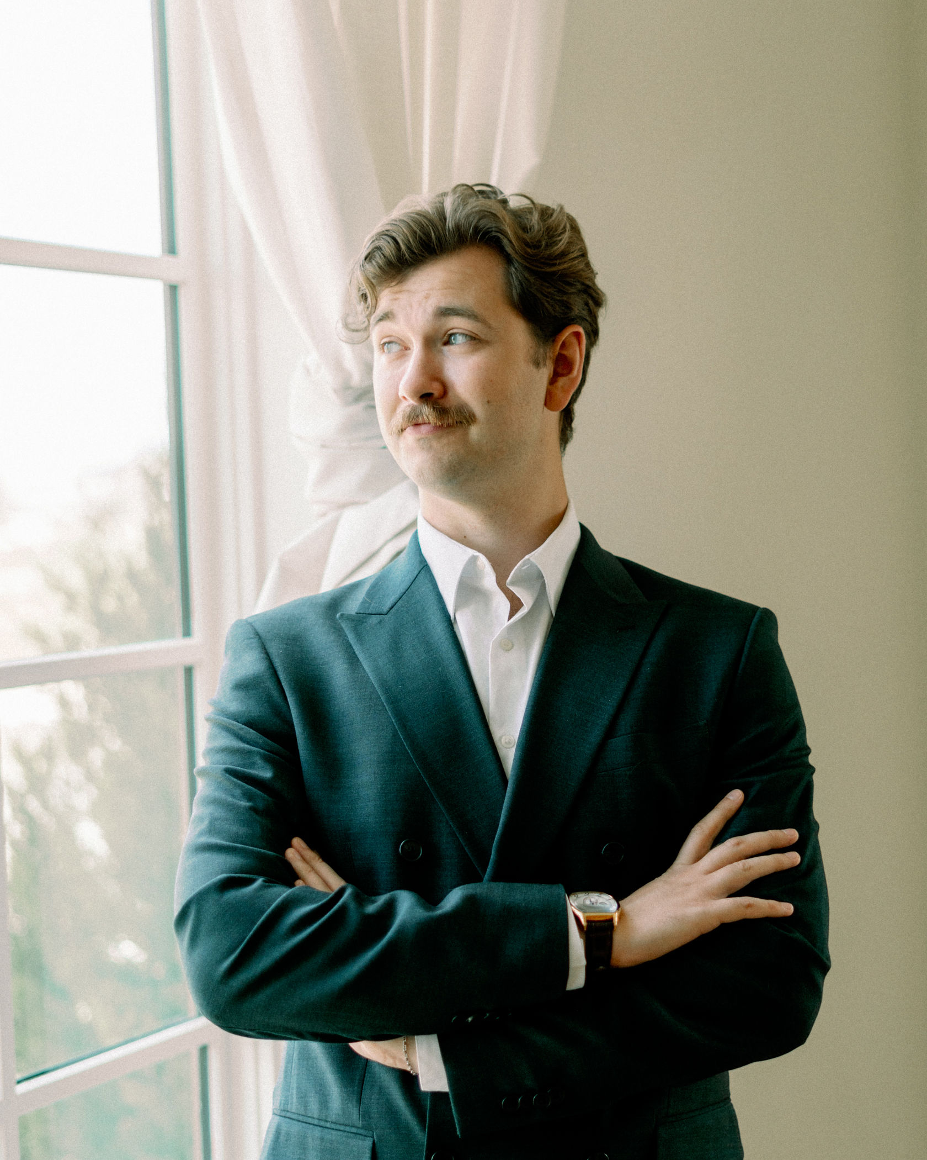

Tres Hunter – Bass

University of North texas
Vocal Performance, BM (2017- 2022)
4.0 GPA – President’s List
Member of Pi Kappa Lambda Honor Society

Voice teachers
Dr. Stephen Morscheck
Bert Johnson
Dr. Stephen Austin (University of North Texas)

coaches
Mary Dibbern
Willem Van Schalkwyk
Brian Holman
Robert Frankenberry
Stephen Dubberly

King/Businessman The Little Prince Dallas Opera Outreach 2025-26
Vertigo Pépito Dallas Opera Outreach 2024-25
Jesus St. John Passion (Chilcott) HPPC Dallas 2024
Gustav Klimt/MOPP Egon Schiele Jared Schwartz Workshop 2024
Vodník Rusalka Opera Arlington 2024
Polifemo Acis y Galatea American Baroque Opera 2023
Don Alfonso Cosi fan tutte Opera Arlington 2023
Gerard Noir Gerard Noir Jared Schwartz Studio 2023
Osmin The Billy Goats Gruff Dallas Opera Outreach 2022-24
Caino Il Fratricidio di Caino Baroko Fest. 2022 - Olomouc, CZ
Collatinus The Rape of Lucretia UNT Opera 2022
Raimondo Lucia di Lammermoor UNT Opera 2020
**postponed due to COVID-19

Additional engagements/Competitions
2nd place winner – Texas Camarata Baroque Aria Competition
Bass Soloist – Handel’s Messiah, Beethoven Messe in C, Mozart Reqiuem, Verdi Reqiuem
Bass Vocalist – Hong Kong Disneyland (2021)
Chorister - Dallas Opera Chorus, Carmen (2025) Don Carlo (2026)

contact info
Telephone: 940-224-8032
Email: treshuntermusic@gmail.com

